AXA e-Notification Project
Operation Guide

Project Details
Application Name | AXA e-Notification Project
Project No. | HK610
Project Name | AXA e-Notification Project

Document Signed Off By
Department | Name  Firstname & Surname & Title | Signature | Date
Business
- Business Manager

IT
- Delivery Manager

Document Distribution List
To / CC | Name  Firstname & Surname & Title | Department
To:
Cc:

Document Control
Version  Number  n.n | Issued  On Date  YYYY/MM/DD | Author(s)  Firstname & Surname  & Title | Reviewer(s)  Firstname & Surname  & Title | Change Description
1.2 | 2016/12/21 | Edward Leung (Atos) |  | 2nd Revision

TABLE OF CONTENTS

1. Overview 4
1.1 System Overview 4
1.2 System Architecture 5
1.3 Functional Modules / Category of Use Case 6
1.4 Role of S&M Team Members 7
2. Routine monitoring health check 8
2.1 Business as Usual S&M Activities 8
2.1.1 Health Check by login to CG Web Portal 8
2.1.2 Health Check by login to CG Web Portal 8
2.1.3 Check Any Error File for Daily Download (G400/EB/PSEA/RLS) 9
2.1.4 Check RCMS sent files to CG 11
2.1.5 Check any error in RCMS files 11
2.1.6 Update HK Holiday 11
2.1.7 Incident Offline 13
2.1.8 Suppress Send Notification to specific product group, channel code, Touchpoint 14
3. JBoss Maintenance 18
3.1 Stop / Start JBoss Server 18
3.2 JBoss Deployments War 19
4. Period server restart procedure 21
4.1 Restart Communication Gateway (CG) 21
4.2 Restart Communication Gateway (Other Machines) 21
5. Password Reset 22
5.1 Change SQL Server Password (CG) 22
5.2 Change SQL Server Password (NHR) 22
5.3 Procedures to carry out after database password amendment 23
5.4 Change Domain Administrator Password (CG) 23
5.5 Change Domain Administrator Password (NHR) 24
6. Troubleshooting Scenarios 25
6.1 CG Users cannot login 25
6.2 No Notification for Approval 25
6.3 No SMS/Email Delivered to Recipients 26
6.4 Unexpected notification content 28
6.5 iPro / SCRUM cannot inquire the notification status from NHR 28
7. Appendix 29
7.1 VPN Connection 29
7.2 Server Host Name and IP Address of CG 30
7.3 Server Host Name and IP Address of NHR 30

Overview

System Overview
Similar to the mail merge function in MS-Word which combines a list of tabular data with pre-defined template to the final form of documents, e-Notification is a solution to facilitate the automation of notification message generation by combing data from backend systems with templates defined by authorized users. With the help of e-Notification Gateway System, the sending of notification messages will be scheduled by automated system without human interventions and all users activities will be logged for auditing purpose.

All raw notification message from core systems will be generated on schedule for Sub Business Line operators’ approval, upon approval, combined message will deliver to communication sub-system (AbleMobile) for notification delivery. The establishment of e-Notification gateway can boost the efficiency and accuracy electronic communications of AXA to her customers and business partners.

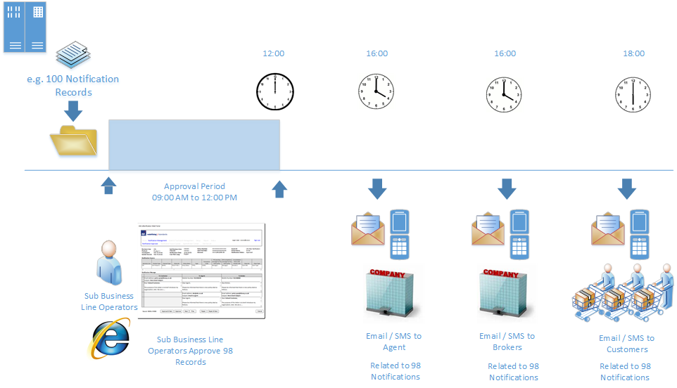

Another core function of e-Notification Gateway is to in-corporate the e-notification mentioned above with existing iPro/SCRUM system. Notification requests triggered by those systems can go through e-Notification Gateway and ultimate all notification sending history can be centralized in one repository for inquiry.

System Architecture
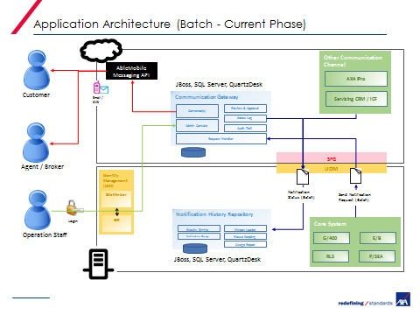
Figure 1 - Notification Triggered by Files download from Core System

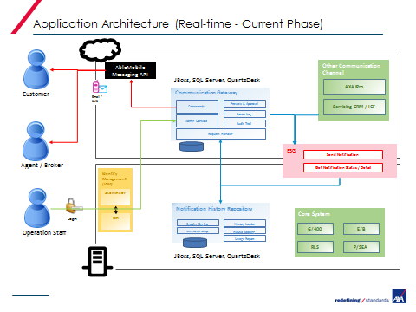
Figure 2 - Notification Triggered by iPro/SCRUM web api call

Functional Modules / Category of Use Case
To fulfil the business objectives stated in the previous section, there are four functional modules to be developed. They are:

- Communication Gateway Web Portal – CG Web Portal
- Communication Gateway Scheduler Task – CG Scheduler
- Notification History Repository API – NHR API

The diagram below shows the location where the module above located.
Communication Gateway (Cloud)

(1) CG Web Portal
(2) CG Scheduler

Notification Repository History (NRH)
(3) NHR API

Role of S&M Team Members
- Routine Monitoring Health Check on CG/NHR operations
- Application Monitoring Reporting
- Daily Interface Files Delivery Status Health Check
- Message Notification Sending
- Periodic System Restart
- Password Renewal

During user requirement definition, S&M team members can access the following CG web portal.

 |  | Application Administrators | Business Line Administrators | Sub Business Line Administrators | Sub Business Line Operators | Customer Service Operators | S & M Team
Notification Management | Notification Approval |  |  |  | ✓
Notification Management | Notification Source Upload |  |  |  | ✓
Notification Management | Channel Contact |  | ✓
Notification Management | Opt Out List |  |  |  | ✓
Event & Touchpoint Management | Event |  | ✓ | ✓ | ✓
Event & Touchpoint Management | Touchpoint |  | ✓
Setup | User | ✓ | ✓ | ✓ |  |  | ✓
Setup | Region | ✓ |  |  |  |  | ✓
Setup | Business Line | ✓
Setup | Sub Business Line | ✓
Setup | Channel | ✓
Setup | Holiday | ✓ |  |  |  |  | ✓
Setup | Product Group |  | ✓
Setup | Product |  | ✓
Setup | File Field Mapping | ✓
Setup | Code Description Mapping | ✓
Setup | Application Setting | ✓ |  |  |  |  | ✓
Report | Notification History |  | ✓ | ✓ | ✓ | ✓ | ✓
Report | Daily Activity |  | ✓ | ✓ | ✓ | ✓ | ✓
Report | Monthly Usage |  | ✓ | ✓ | ✓ | ✓ | ✓
Report | Audit Log | ✓ |  |  |  |  | ✓
Status | System Health Dashboard |  |  |  |  |  | ✓
Status | Freeze / Unfreeze Message Component | ✓ |  |  |  |  | ✓
Switch Business Line | Switch Business Line | ✓ |  |  |  |  | ✓

In the following sections, procedure related to the above roles will be presented to S&M members

Routine monitoring health check

Business as Usual S&M Activities

Health Check by login to CG Web Portal
1. Login to CG Web Portal
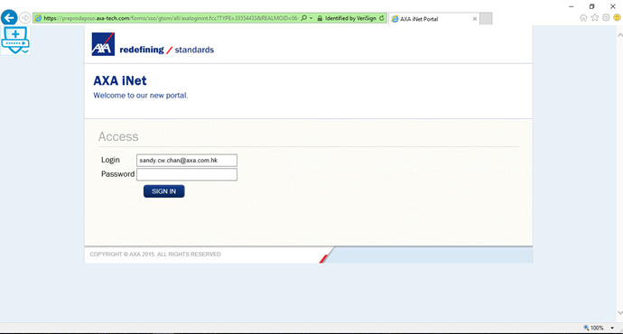

2. It login successful, it is OK.

Health Check by login to CG Web Portal
To check CG system health, carry out the tasks as follows:

1. Login to CG Web Portal
2. Go to Notification Source Upload Page
3. Input T-1 (e.g. 2016/10/26 if today is 2016/10/27) business date and search
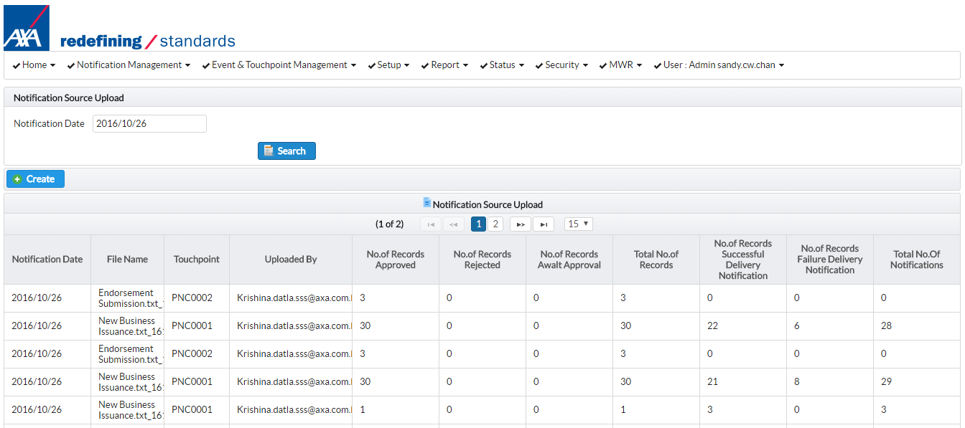
4. Check all files can be received

Check Any Error File for Daily Download (G400/EB/PSEA/RLS)

- Login to sftp.e-service-axa.com.hk using WinSCP or other related sftp client
- Go to /cygdrive/d/repos/cg/input/NotificationSource/core/error

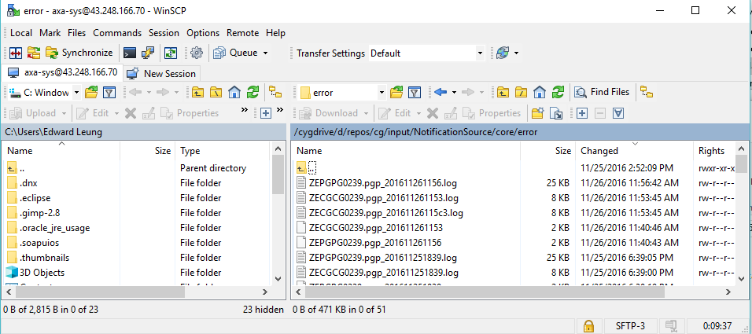

- Sort the file date by clicking the Change column as follows
Sort by Date in Descending Order
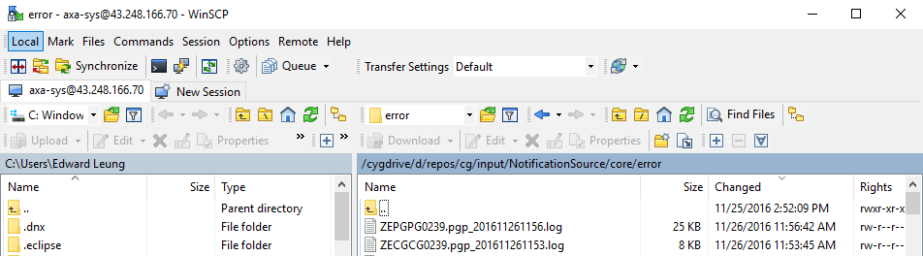

For any file which could not be processed by CG, it will have FILE_NAME_time.log created in the error folder. Download this file and send to application team for troubleshooting.

Error file ZEPGPG0239.pgp error
Related file cannot have touchpoint mapped

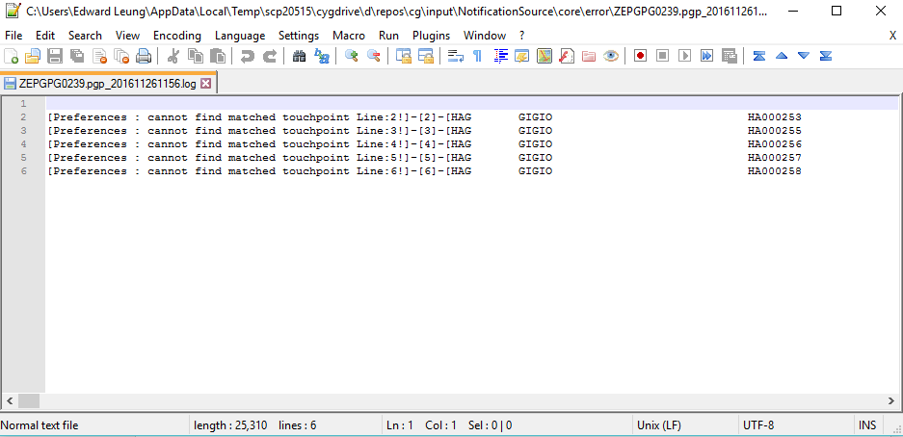

The related encrypted file will be also place in the folder. S&M team member can send this file to application team for troubleshooting.

ZEPGPG0239.pgp file

Check RCMS sent files to CG

- Login to sftp.e-service-axa.com.hk using WinSCP or other related sftp client
- Go to /cygdrive/d/repos/cg/input/ChannelContact/core/backup

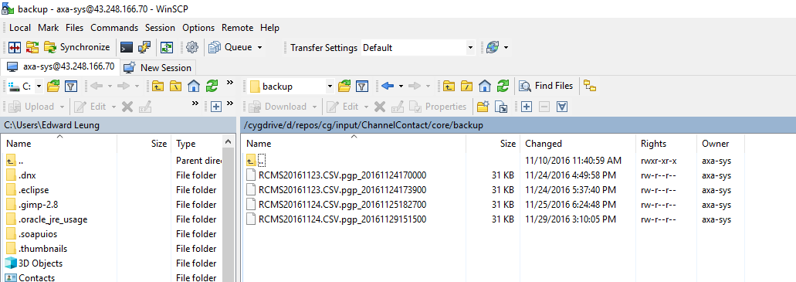

- See whether you give the files with

Check any error in RCMS files

- Login to sftp.e-service-axa.com.hk using WinSCP or other related sftp client
- Go to /cygdrive/d/repos/cg/input/ChannelContact/core/error

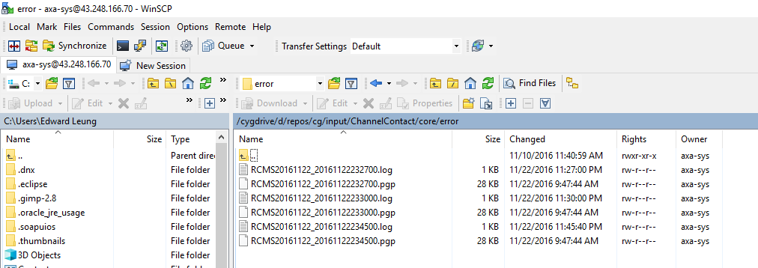

Update HK Holiday

- Login to CG Web Portal
- Go to Setting > Holiday
- Click Create
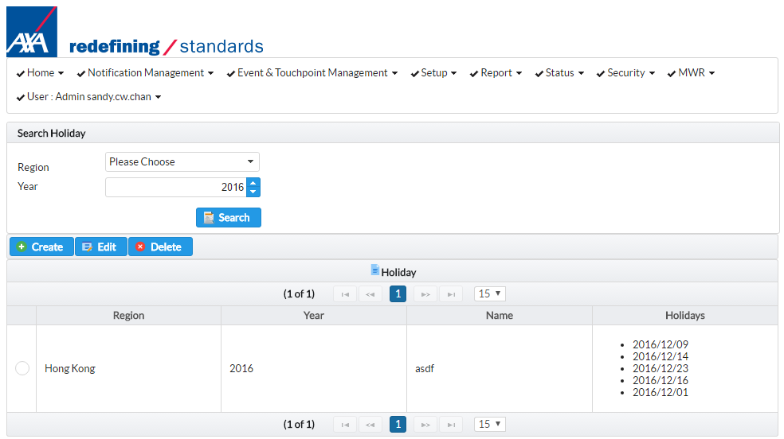
- Select Region “Hong Kong”.
- Input Year (e.g. 2017)
- Double click the date in the calendar control. The date will add in the list below
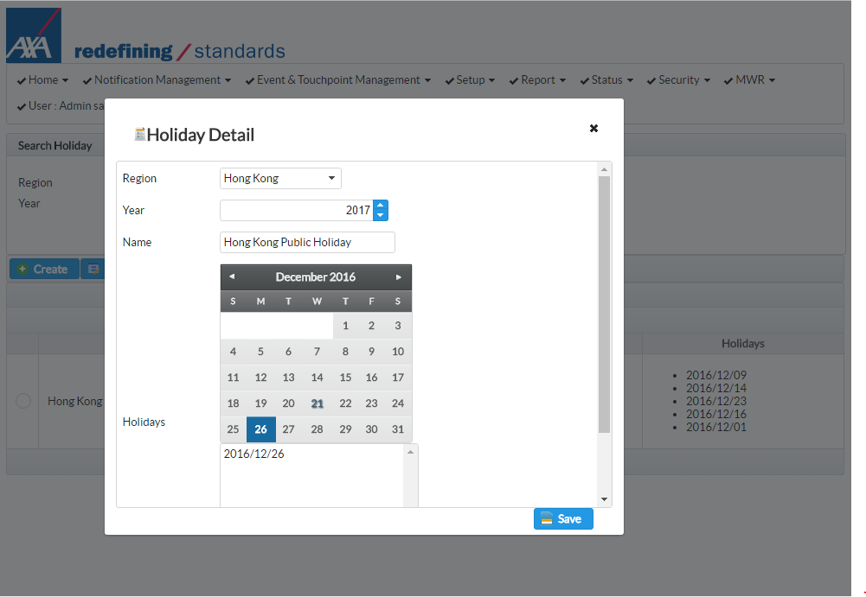
Double click
Holiday selected

*SAT/SUN is not required to input

- It is not allowed to select date two times.
- Once all dates inputted, click Save to finish

Incident Offline
* The procedures below freeze the sending of notification

- Login to CG Web Portal
- Go to Status > Freeze / Unfreeze Message Sending
- You can see the current status is Running. Click Freeze

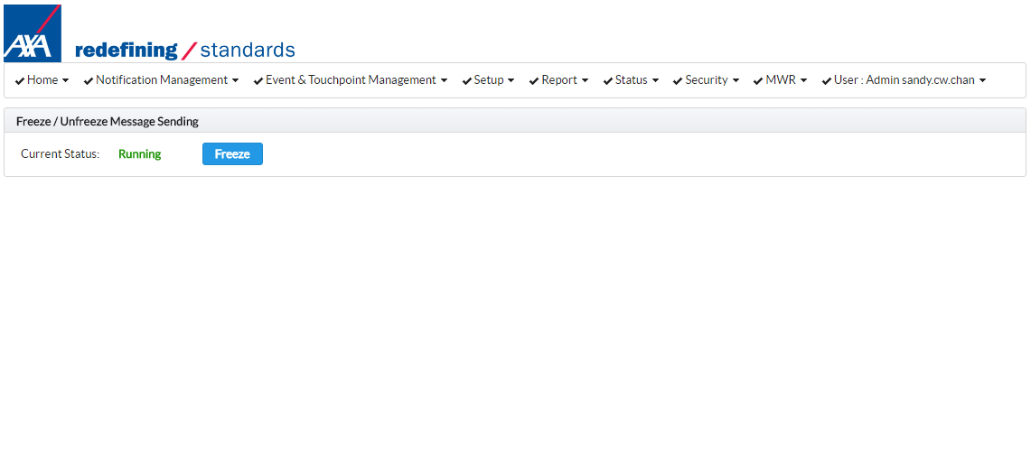
Current status
Click Freeze
To resume the sending of message:

- Login to CG Web Portal
- Go to Status > Freeze / Unfreeze Message Sending
- You can see the current status is Stopped. Click Unfreeze
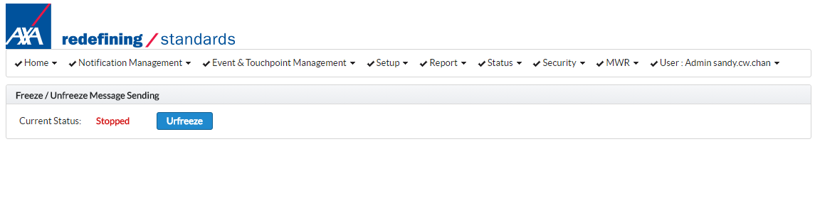
Current status
Click Unfreeze

Suppress Send Notification to specific product group, channel code, Touchpoint
- Login to CG Web Portal
- Select related business line and click Continue button. You should see a green box appears at the top right corner showing that update carried out successfully.
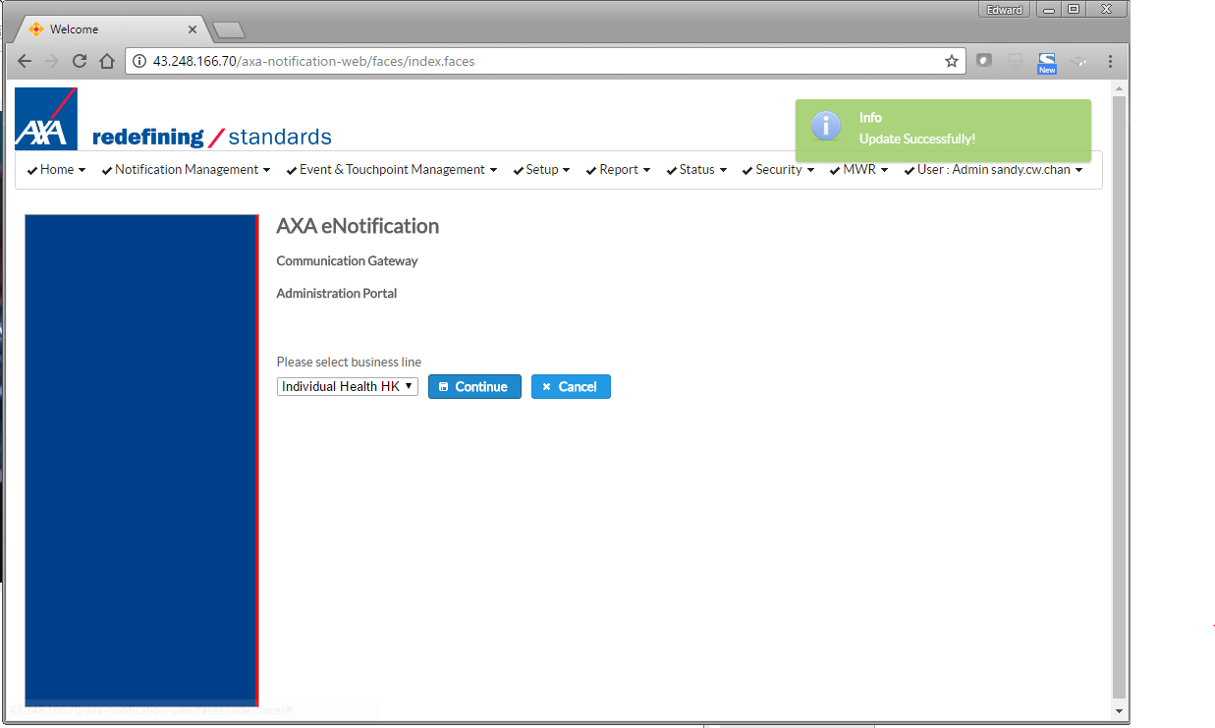

- Go to Event & Touchpoint Management
- Select the TouchPoint you want to suppress, click Edit button

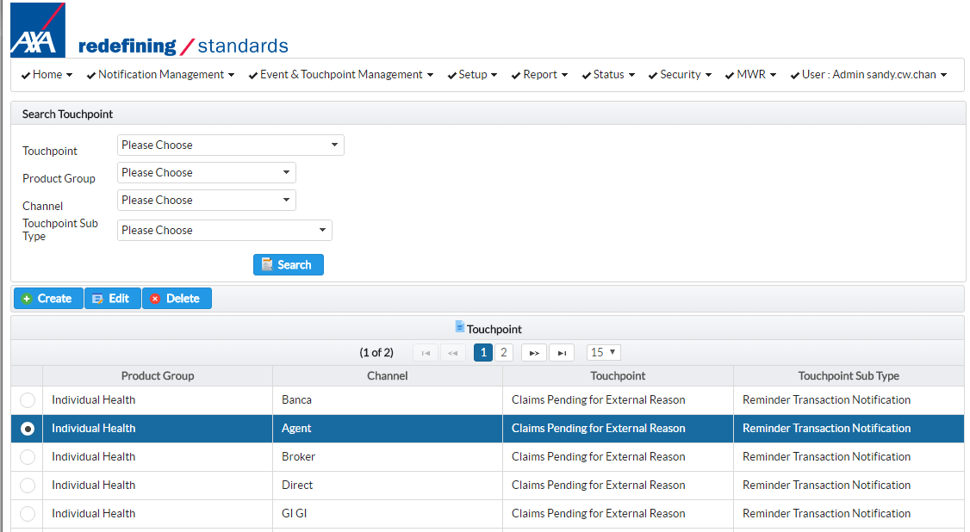
Current status
2. Click Edit
1. Select record

- Click In-active and click Save
1. Select Inactive

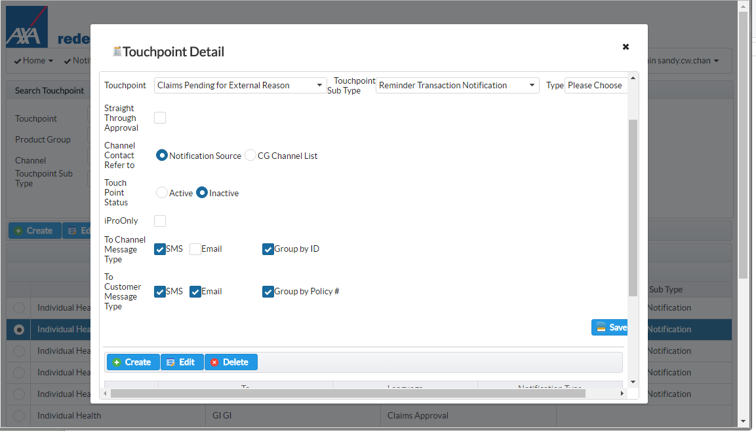
2. Click Save

- The touchpoint will not have message send out on next business date.

Input System Date
Last Action Date (e.g. 2016/11/14)

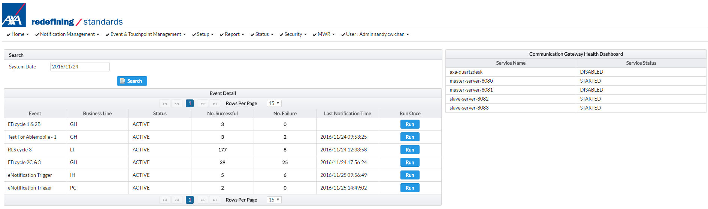
Component running status

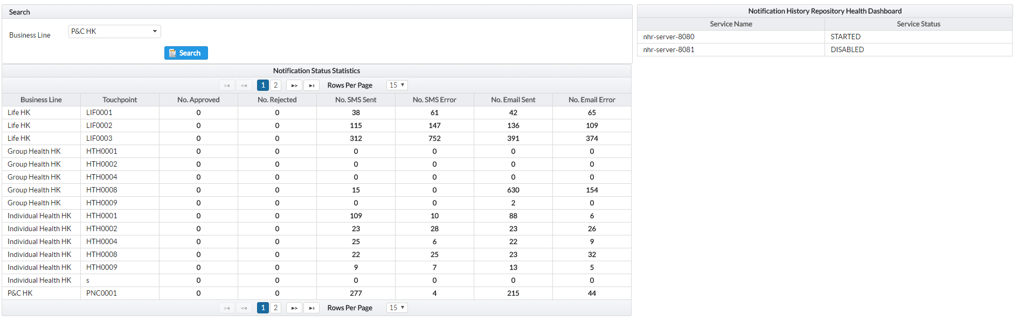
No. of SMS/Email sent according to System input
Business Line selected for searching

Service Name Description

Location | Name | Usage
CG | cg-master-server | JBoss cluster nodes server name. Please refer to 2.1.1
CG | cg-salve-server-8090 | JBoss cluster nodes server name. Please refer to 2.1.1
NHR | nhr-master-server | JBoss cluster nodes server name. Please refer to 2.1.1
NHR | nhr-slave-server | JBoss cluster nodes server name. Please refer to 2.1.1

For each for the server name have status not equal to STARTED. Please follow the procedures to restart the server.

JBoss Maintenance

Stop / Start JBoss Server
1. Login in jboss console: http://172.29.52.24:9990/console
2. Input user id: adminJboss, password: P@ssw0rd
3. Go to Domain > Overview
4. Place the cursor to the host group. Select Start Group / Stop Group / Restart Group
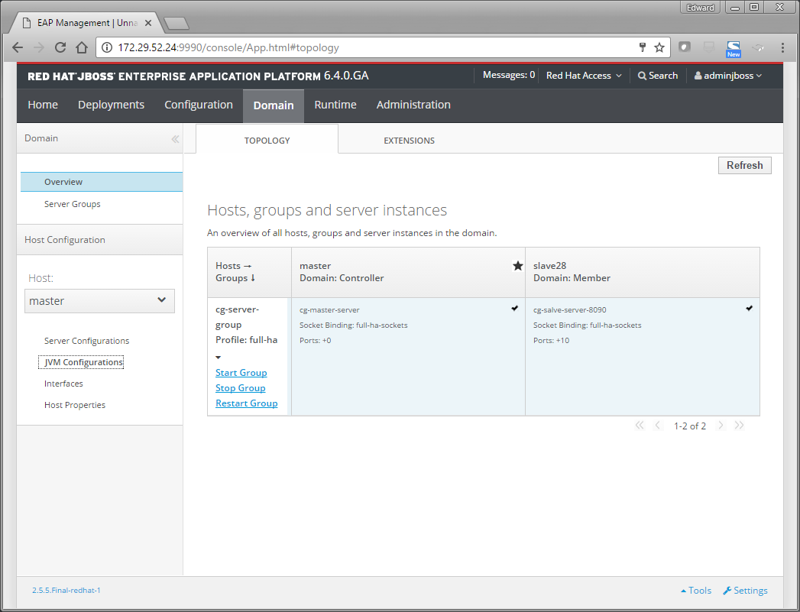

JBoss Deployments War
Select Deployments tab in jboss console

1. Login in jboss console: http://172.29.52.24:9990/console
2. Input user id: adminJboss, password: P@ssw0rd
3. Go to Deployments, click Replace button
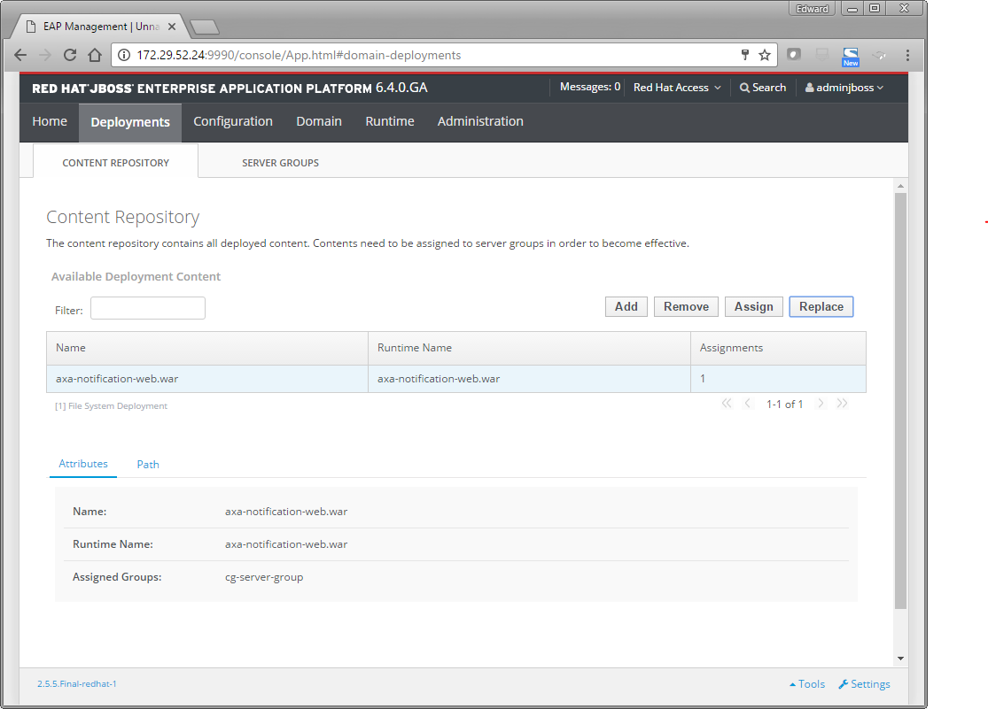

4. Go to Deployments, click Replace button. Click Choose File. The name of the war must be axa-notification-web.war.

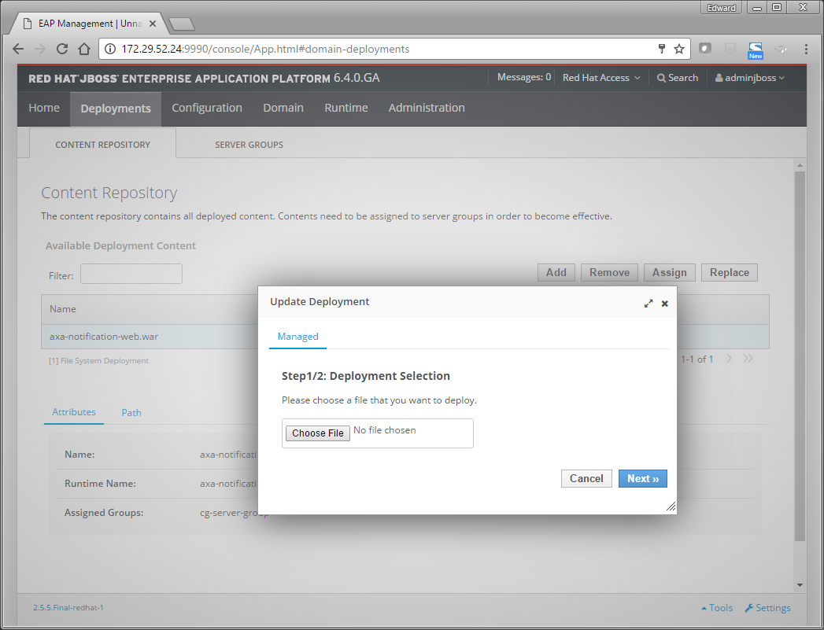

5. Click Next to complete the process.
6. Go to Overview, restart the server group to finish the deployment.

Refer to the following link for more information:

https://access.redhat.com/documentation/en-US/JBoss_Enterprise_Application_Platform/6.4/html/Administration_and_Configuration_Guide/sect-Start_and_Stop_JBoss_EAP_6.html#Start_JBoss_EAP_6

Period server restart procedure

Restart Communication Gateway (CG)
- Login to Communication Gateway (172.29.52.24 / 172.29.52.28).
- Check whether there are job running using QuartzDesk console.
- In Start menu, select Shutdown Server (Domain) – red color.
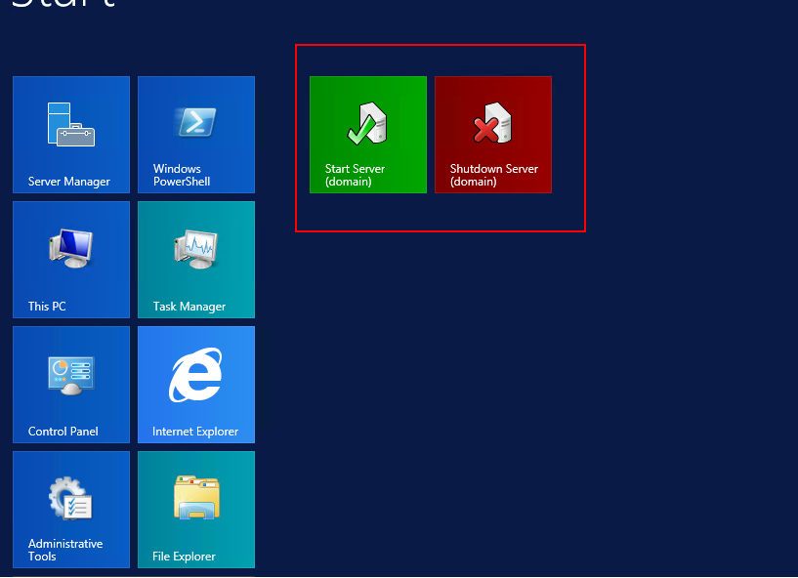
- Once the JBoss server shutdown. Click  to restart the server.
- After re-start, click Start menu and click Start Server (Domain) – green color.
- Ensure 172.29.52.24 / 172.29.52.28 restarted properly.

Restart Communication Gateway (Other Machines)
- Login to server (e.g Proxy server, Activity Directory Server, SQL Server)

- Click to restart the server.

Password Reset

Change SQL Server Password (CG)
- Login to CG Database Server (172.29.52.23 / 172.29.52.29) as domain administrator (PRD\Administrator).
- Click Start, search SQL Server 2014 Management Studio
- Go to Server Name > Security > Logins > axa_cg, right click and select Properties…

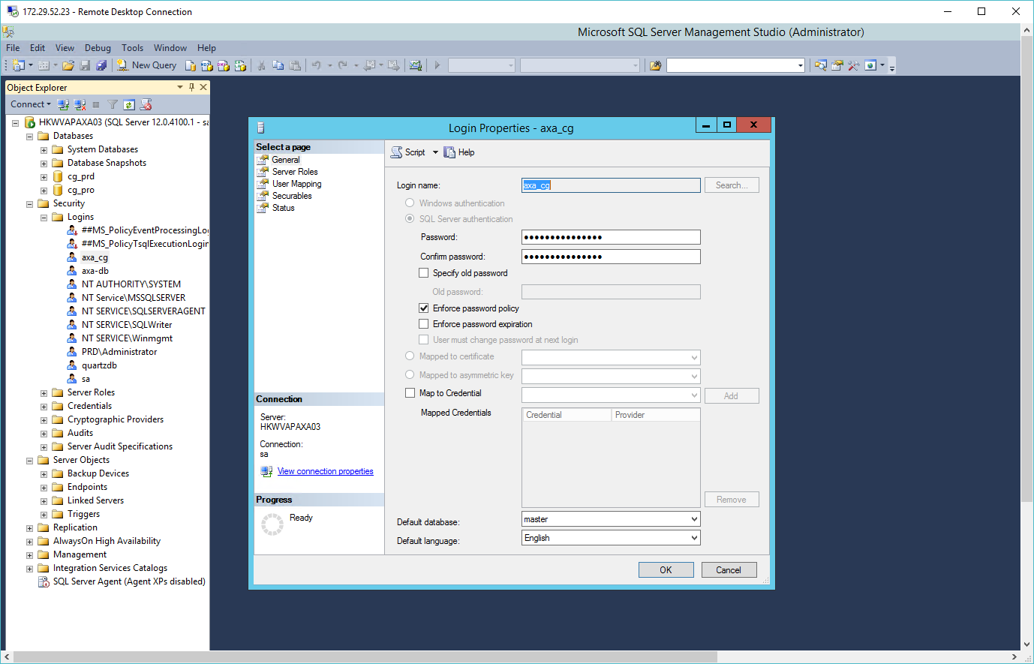

- Click OK to continue.
- For axa-db, follow similar steps to change SQL Server passwords.

Change SQL Server Password (NHR)
- Login to NHR Database Server (172.29.52.30 / 172.29.52.33) as domain administrator (NHR\Administrator).
- Click Start, search SQL Server 2014 Management Studio
- Go to Server Name > Security > Logins > axa_nhr, right click and select Properties…

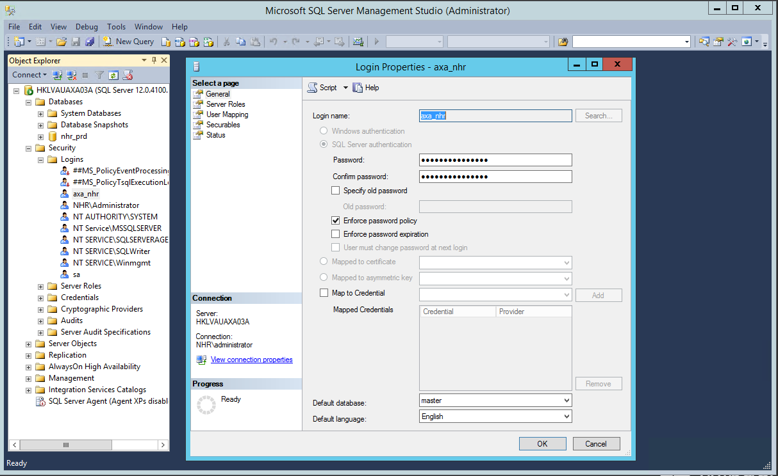

- Click OK to continue.

Procedures to carry out after database password amendment
- Use the password encryption jar to encrypt the password to encrypted string.
- Update related configuration file.
- Follow JBoss war file deployment process to update the latest war file

Change Domain Administrator Password (CG)
- Login to Domain Controller of CG (172.29.52.21 / 172.29.52.25) as domain administrator (PRD\Administrator).
- Search Active Directory Users and Computers.
- In PRD domain, go to user part and right click Administrator.

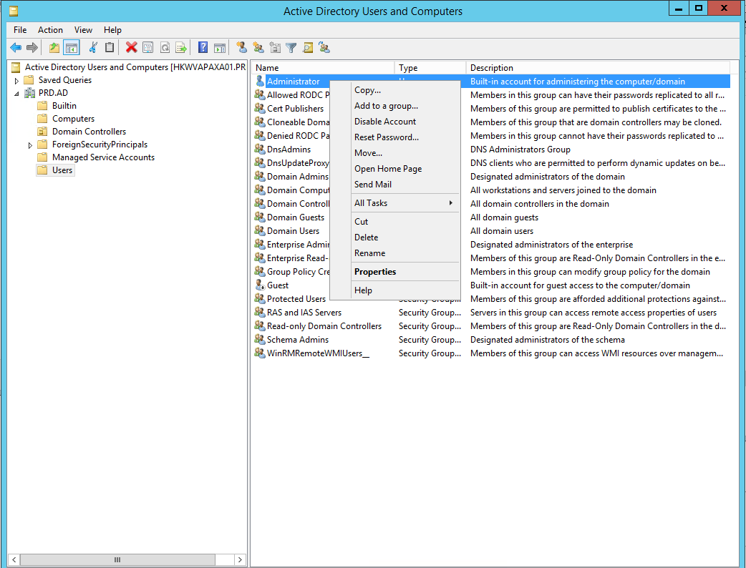

- Input new password and confirm password and click OK.

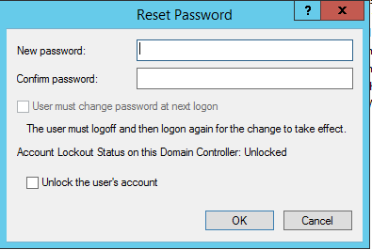

- Restart the domain controller afterwards.

Change Domain Administrator Password (NHR)
- Login to Domain Controller of CG (172.29.52.29 / 172.29.52.32) as domain administrator (NHR\Administrator).
- Search Active Directory Users and Computers.
- In PRD domain, go to user part and right click Administrator.

- Input new password and confirm password and click OK.

- Restart the domain controller afterwards.

Troubleshooting Scenarios

CG Users cannot login
1. Login to CG Web page, if it cannot login, report incident to ATOS
2. Login using support a/c
3. Go to Users, check reported user ID registered in database or not. If not, contact S&M team to create account.
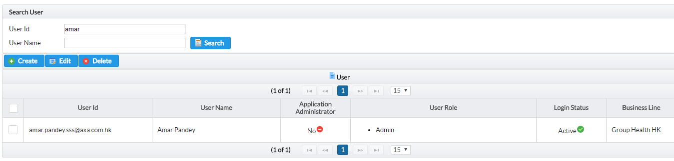

4. If account found and status is correct, report Incident to ATOS.

No Notification for Approval
1. Login to CG Web page
2. Go to Notification Source Upload Page
3. Input T-1 (e.g. 2016/10/26 if today is 2016/10/27) business date and search
4. Check all files can be received
5. If no file downloaded, contact related system team
6. Report incident to ATOS for other errors

No SMS/Email Delivered to Recipients
1. Login to CG Web page
2. Go to system health dashboard, select current date (e.g. 2016/12/02 if today is 2016/10/02) and check any error run on the current date or not.
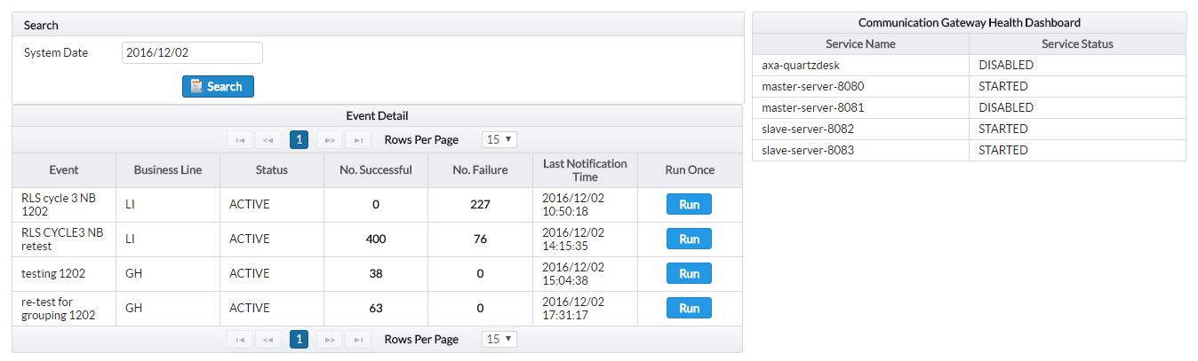

3. Go to system health dashboard, select T-1 date and check TouchPoint has successful message sent or not
If today is 2016/12/03, T-1 equal to 2016/12/02
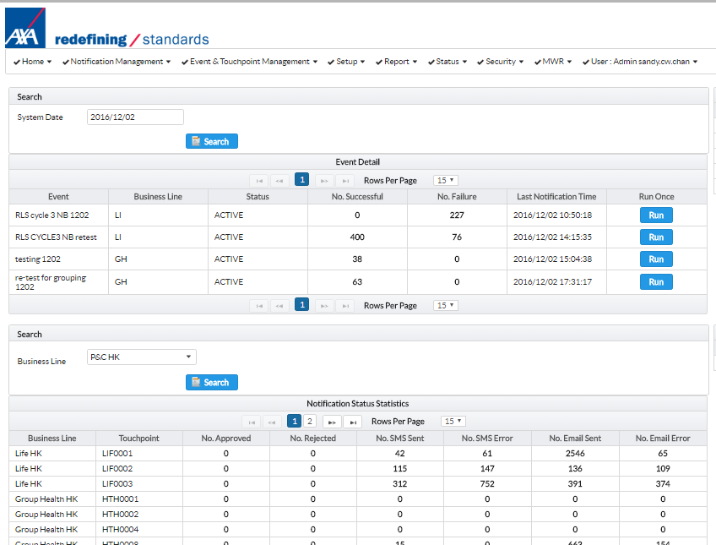

4. Go to Notification Approval. Identify problem due to notification source / operator not approve.
If operator not yet approve transaction, email/SMS will not send out

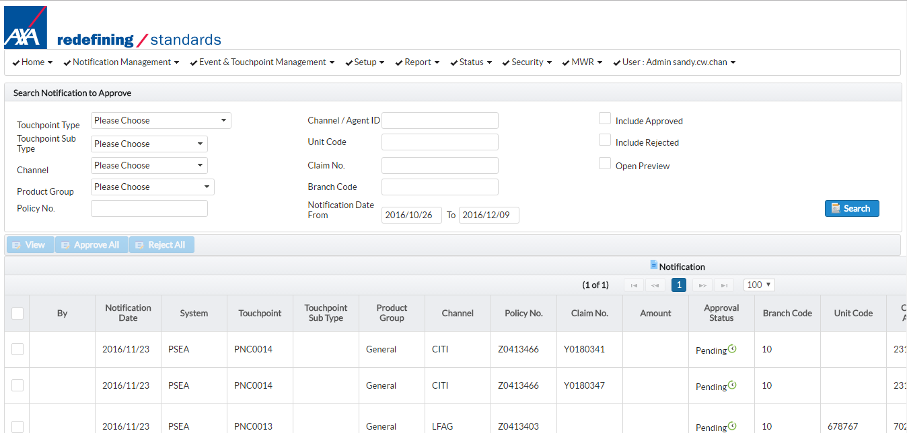

5. Go to Notification History Inquiry. Identify problem due to AbleMobile not function or not.
SMS Delivery Status

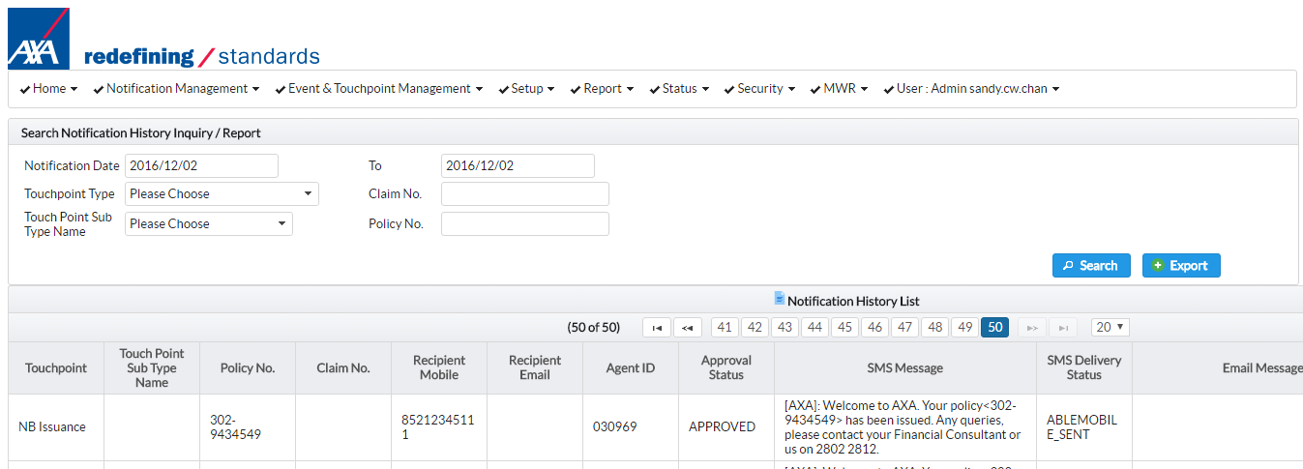

6. If related to notification source, contact Core System Team
7. If related to operator not yet approve record, asked them to approve
8. If related to AbleMobile, contact AbleMobile support Team
9. For others, report incident to ATOS

Unexpected notification content
1. Report incident to Business Line Administrators / End Users BA
2. If it is not related to template definition, report incident to ATOS

iPro / SCRUM cannot inquire the notification status from NHR
1. Login to CG Web page
2. Go to Notification History Inquiry. Search notification date for the last five business date. To check any record returned.

Input last business date record for searching

3. If there is record found, it means NHR Web API works properly. Contact iPro/SCRUM team.

4. If there is error returned, report incident to ATOS.

Appendix

VPN Connection
- Go to https://43.248.166.66 (download VPN client). (skip if FortiClient already installed)
- Login xxxxxx / xxxxxxx
- After login, download FortiClient Windows and install it
- After install, click Configure VPN
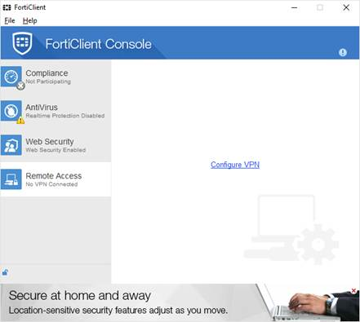

- Input thing below, click Apply and Close
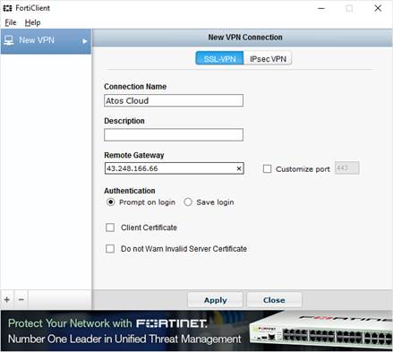

Server Host Name and IP Address of CG
# | Host Name | IP Address | Server Usage
1 | HKWVAPAXA01 | 172.29.50.21 | Active Directory Domain server / SQL Witness Server
2 | HKWVAPAXA02 | 172.29.42.22 | Application Proxy server
3 | HKWVAPAXA03 | 172.29.52.23 | Database server / Communication Gateway
4 | HKWVAPAXA04 | 172.29.52.24 | Application server
5 | HKWVASAXA01 | 172.29.52.25 | Active Directory Domain server / SQL Witness Server (DR)
6 | HKWVASAXA02 | 172.29.42.26 | Application Proxy server (DR)
7 | HKWVASAXA03 | 172.29.52.27 | Database server/Communication Gateway(DR)
8 | HKWVASAXA04 | 172.29.52.28 | Application server/Communication Gateway (HA) (DR)

Server Host Name and IP Address of NHR
# | Host Name | IP Address | Server Usage
1 | HKLVAUAXA02A | 172.29.42.27 | Application Proxy server
2 | HKLVAUAXA02B | 172.29.42.28 | Application Proxy server (DR)
3 | HKLVAUAXA01A | 172.29.52.29 | Active Directory Domain server / SQL Witness Server
4 | HKLVAUAXA03A | 172.29.52.30 | Database server Communication Gateway
5 | HKLVAUAXA04A | 172.29.52.31 | Application server Communication Gateway (HA)
6 | HKLVAUAXA01B | 172.29.52.32 | Active Directory Domain server / SQL Witness Server (DR)
7 | HKLVAUAXA03B | 172.29.52.33 | Database server/Communication Gateway(DR)
8 | HKLVAUAXA04B | 172.29.52.34 | Application server/Communication Gateway (HA) (DR)

RCMS - Regional Channel Management System

